

National College of Ireland
BSHC in Computing
Cyber Security
2025
Liam Connell
X22511759
X22511759@student.ncirl.ie

Currently
Technical Report

Contents
Executive Summary 3
1.0 Introduction 3
1.1. Background 3
1.2. Aims 4
1.3. Technology 4
1.4. Structure 5
2.0 System 5
2.1. Requirements 5
2.1.1. Functional Requirements 5
2.1.1.1. Use Case Diagram 6
Use Case List 6
Use Case 1: Create Account 7
Use Case 2: Log In 8
Use Case 3: Create Room 9
Use Case 4: Add Appliance to Room 10
Use Case 5: Watch Your Watts 11
2.1.2. Data Requirements 13
2.1.3. User Requirements 15
2.1.4. Environmental Requirements 15
2.1.5. Usability Requirements 15
2.2. Design & Architecture 16
Architectural Style 16
Tech Stack Interaction Diagram 16
High level Components 17
Security Architecture (Auth and Access Contril) 18
Data Architecture (current and planned**) 18
Data Flow Overview 19
2.3. Implementation 19
2.4. Graphical User Interface (GUI) 20
2.5. Testing 24
2.6. Evaluation 24
3.0 Conclusions 24
4.0 Further Development or Research 24
5.0 References 25
6.0 Appendices 26
6.1. Project Proposal 26
6.2. Reflective Journals 34
Month: September 34
Month: October 35
Month: November 36

Executive Summary
This report outlines the midpoint progress of Currently, a secure web application designed to help households better understand their electricity usage and associated costs. The main aim of the project is to give users clear, appliance-level insight into how energy is used within their home, without relying on smart meters or additional hardware. Alongside this, the project focuses on applying secure software development practices to protect user data and ensure safe access to the system.
The application allows users to register and log in securely before creating a digital representation of their home by adding rooms and floors. Users can then assign common household appliances to these rooms and provide basic usage assumptions, such as how often or how long each appliance is used. Using this information, the system estimates electricity consumption and costs based on standard kilowatt-hour calculations and publicly available Irish electricity pricing. These estimates are intended to support awareness and informed decision-making rather than provide exact billing figures.
At the midpoint stage, several core features have been implemented. Secure authentication using JWT is in place, and users can successfully create and manage rooms through the Map My House feature, as well as assign appliances and usage details using the My Appliances feature. A structured appliance reference dataset has also been developed to provide realistic default values while still allowing users to adjust assumptions to reflect their own usage.
Work remaining in the project includes the development of a dashboard and the “Watch Your Watts” feature, which will present aggregated energy insights and cost forecasts. An optional AI-assisted recommendation feature is also planned to provide advisory suggestions on reducing energy usage. Further stages will focus on testing, security hardening, database migration, and final evaluation before submission.

Introduction

Background
The motivation for Currently started when I read the increase of electricity costs in Ireland and the lack of accessible tools which help ordinary households and people to understand their energy consumption at an appliance level. There is many existing platforms, smart home systems and hardware dependent apps that only present course, bill level data or ask for user investment in smart devices such as smart plugs. Users lack insight into which appliances contribute not energy use and which room that appliance may be in.
Currently will address the gap by giving a Software only Solution that models users home, allows appliances to be assigned to rooms, estimates usage and then visualises consumption trends. The aim is to give insightful information to the user without needed specialised equipment or needing to bypass a paywall all while maintaining strong security controls over user data and authentication.

Aims
Currently aims to create a secure web application that helps users to :
- Create a digital representation of their home using a floor-and-room structure.
- Assign appliances to rooms using a curated dataset of realistic wattage values.
- View estimated electricity consumption and costs at both room and appliance levels.
- Forecast future costs and simulate potential savings through the “Watch Your Watts” feature.
- Interact with a modern, responsive, and intuitive interface that supports practical decision-making.
Another main goal is to make sure I correctly implement security principles which aligns with my choice of the Cyber Security stream, including secure user authentication, safe storage of user and house credentials, controlled access to user data and mitigation on any web security risks

Technology
Currently is implemented as a full stack web application using:
Frontend: React (Vite) with modular components and CSS styling
Backend: Java Spring Boot with Spring Security and JWT Authentication
Database
- SQLite: for local development
- Planned (PostgreSQL): planned migration for deployment, I chose it for its reliability and integration with Spring Data JPA
Supporting Tools:
- Postman for API tests
- PlantUML for system and architecture diagrams
- Notion for project management
- Wireframe.cc for UI prototypes
The tech stacks give Currently modularity, portability and strong security foundations

Structure
The structure of this report is following the template required by National College of Ireland
- Section 2 outlines the system requirements, including functional requirements, detailed use cases, data requirements, environmental considerations, and usability goals.
- Section 2.2 presents the overall system design and architecture, describing both frontend and backend components and how they interact.
- Section 2.3 discusses the implementation to date, highlighting core classes, services, and algorithms.
- Section 2.4 presents the Graphical User Interface with annotated screenshots.
- Section 2.5 summarises testing activities, covering unit, integration, and manual evaluation.
- Section 2.6 reflects on the efficacy, correctness, and limitations of the current system.
- Section 3 presents conclusions.
- Section 4 outlines opportunities for further development.
- Section 5 provides references.
- Section 6 contains appendices such as sprint logs, the proposal, and reflections

System

Requirements
These requirements describe what the system must accomplish and how it will behave from the perspective of a new user. All requirements are verifiable and support my main objectives of Currently: secure authentication, accurate modelling of user’s home, appliance assignment and energy usage data exploration.

Functional Requirements
Prioritised Functional Requirements List
- The system must allow a user to create a secure account.
- The system must authenticate a user and issue a valid JWT token.
- The system must allow users to create rooms in their digital home layout.
- The system must allow users to assign appliances to rooms.
- The system must generate usage estimates, cost predictions, and visual insights

Use Case Diagram

Use Case List
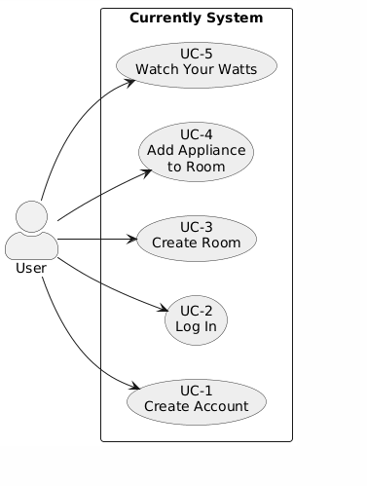

Use Case ID | Use Case Name | Description
UC-1 | Create Account | User registers using a unique email and password.
UC-2 | Log In | User authenticates and receives a JWT token to access private pages.
UC-3 | Create Room | User creates a room within the Map My House feature.
UC-4 | Add Appliance to Room | User selects an appliance and assigns it to a room.
UC-5 | Watch Your Watts | User views charts, cost forecasts, and “Biggest Eaters.”

Use Case 1: Create Account
Use Case ID: | UC-1
Use Case Name: | Create Account
Created By: | Liam Connell | Last Updated By:
Date Created | 27/11/25 | Last Updated Date | 27/11/25
Description: | A new user registers for an account by providing a unique email and password. The system validates inputs, ensures the email is unused, hashes the password, and stores the user in the database.
Actors:  Primary  Secondary | Primary: User  Secondary: None
Triggers: | The user clicks “Sign Up” on the login/registration page.
Pre-conditions: | User does not already exist in the database.  Inputs must be provided in required format.
Post-Conditions: | A new user is created.  User can immediately log in.
Normal Flow: | - User selects “Create Account.”  - User enters email and password.  - System validates inputs.  - System checks if email is already in use.  - System hashes the password using BCrypt.  - System stores the new user in the database.  - System confirms account creation.
Alternate Flows: | A1 – Email already exists:  - System returns an error.  - User is asked to enter a different email.
Exceptions: | Database unavailable → system returns error message.
Includes: | Validate input
Extends: | -
Priority: | High
Special Conditions: | -
Assumptions: | -
Notes and Issues: | -

Use Case 2: Log In
Use Case ID: | UC-2
Use Case Name: | Log In
Created By: | Liam Connell | Last Updated By:
Date Created | 27/11/25 | Last Updated Date | 27/11/25
Description: | The user logs in by providing valid credentials. System verifies password, generates a JWT token, and grants access to private pages.
Actors:  Primary  Secondary | Primary: User  Secondary: None
Triggers: | The user presses “Log In.”
Pre-conditions: | User must already exist.  Password must match the stored hash.
Post-Conditions: | JWT token is issued and stored on client.  User gains access to Dashboard, Map My House, etc.
Normal Flow: | - User enters email + password.  - System checks if user exists.  - System verifies password using BCrypt.  - System generates JWT token.  - System sends token to frontend.  - Frontend stores token (localStorage).  - User is redirected to the dashboard.
Alternate Flows: | Wrong password → System returns error.
Exceptions: | Token generation fails → error returned.
Includes: | Validate input
Extends: | -
Priority: | High
Special Conditions: | -
Assumptions: | User has stable network
Notes and Issues: | -

Use Case 3: Create Room
Use Case ID: | UC-3
Use Case Name: | Create Room
Created By: | Liam Connell | Last Updated By:
Date Created | 27/11/25 | Last Updated Date | 27/11/25
Description: | User adds a new room using the Map My House interface. Room is stored with name and floor label.
Actors:  Primary  Secondary | Primary: User  Secondary: None
Triggers: | User clicks “Add Room” on Map My House.
Pre-conditions: | User must be logged in.  JWT token must be valid.  Floor must be available for room to be stored in
Post-Conditions: | Room is stored in DB under the current user.  Map updates to display the new room.
Normal Flow: | - User opens Map My House.  - User selects “Add Room.”  - User enters room name + floor.  - System validates inputs.  - System creates room in DB.  - System returns updated room list.  - UI refreshes to show the new room.
Alternate Flows: | Missing information → System asks user to complete fields.
Exceptions: | Database write failure → error displayed.
Includes: | Validate input
Extends: | -
Priority: | High
Special Conditions: | -
Assumptions: | User has created at least one floor (or default floor exists).  Notes: Rooms table and user foreign key must exist.
Notes and Issues: | -

Use Case 4: Add Appliance to Room
Use Case ID: | UC-4
Use Case Name: | Add Appliance to Room
Created By: | Liam Connell | Last Updated By:
Date Created | 27/11/25 | Last Updated Date | 27/11/25
Description: | User selects an appliance from the appliance dataset and assigns it to a room. System stores wattage + usage pattern in user_appliances.
Actors:  Primary  Secondary | Primary: User  Secondary: None
Triggers: | User clicks “Add Appliance” in “My Appliances” page.
Pre-conditions: | User logged in.  Room exists.
Post-Conditions: | New appliance instance stored in DB.  Dashboard and Watch Your Watts can now include it in calculations.
Normal Flow: | - User selects room.  - User clicks “Add Appliance.”  - Appliance list loads from backend dataset.  - User selects an appliance + usage details.  - System validates data.  - System creates user_appliance row.  - System returns updated appliance list.  - UI refreshes to show the appliance.
Alternate Flows: | Invalid usage input → system prompts for correction.
Exceptions: | Reference dataset missing → system shows error.
Includes: | Appliance dataset retrieval
Extends: | -
Priority: | High
Special Conditions: | -
Assumptions: | Appliance dataset exists in JSON or backend memory.  Notes: Applies wattage at time of assignment.
Notes and Issues: | -

Use Case 5: Watch Your Watts
Use Case ID: | UC-5
Use Case Name: | Watch Your Watts
Created By: | Liam Connell | Last Updated By:
Date Created | 27/11/25 | Last Updated Date | 27/11/25
Description: | The user views appliance-level and room-level consumption charts, “Biggest Eaters,” and cost forecasts. The system also uses an AI-based recommendation engine (planned) to suggest practical ways to reduce energy usage based on the user’s current appliance setup and usage patterns.
Actors:  Primary  Secondary | Primary: User  Secondary: None
Triggers: | The user opens the “Watch Your Watts” page.  Optionally, the user clicks a button such as “Get AI Tips” or “Suggest Savings” (planned).
Pre-conditions: | User is logged in and has a valid JWT token.  At least one appliance is assigned to a room in the user’s profile.
Post-Conditions: | User sees cost projections, usage estimates, energy breakdown, and (where available) AI-generated suggestions for reducing usage.
Normal Flow: | - User opens the Watch Your Watts page.  - Backend loads user appliances and appliance reference data.  - System calculates kWh per appliance based on wattage and usage parameters.  - System calculates estimated cost using the configured electricity rate (€/kWh).  - System identifies the top 5 “Biggest Eaters” based on consumption.  - System aggregates data per room for visualisation.  - Frontend displays charts and summary statistics.  - (Planned) User clicks “Get AI Tips.”  - (Planned) System sends relevant usage and appliance data to the AI recommendation module.  - (Planned) AI module generates suggestions (e.g. “Reduce tumble dryer use by 1 hour/day to save €X/month”) and returns them to the frontend.  - (Planned) Frontend displays suggestions alongside charts.
Alternate Flows: | A1: No appliances added  - System detects that no user_appliances exist.  - System displays an informative empty state (e.g. “Add appliances in My Appliances to see insights.”) instead of charts and AI tips.  A2: AI module not available (planned feature)  - System shows charts and forecasts only.  - “Get AI Tips” button is hidden or disabled.
Exceptions: | - Calculation error or missing reference data → system logs error and shows a generic message while avoiding crashes.  - AI service timeout or error → system skips AI suggestions and displays charts only
Includes: | Analytics engine (consumption + cost calculation).  (Planned) AI recommendation engine for savings suggestions.
Extends: | Extends the underlying “View Dashboard data” behaviour with more detailed analytics.
Priority: | High  AI plans: Medium
Special Conditions: | AI recommendations must not override user control; they are advisory only.
Assumptions: | AI engine is either internal (model hosted server-side) or via a secure external API with appropriate data protection.
Notes and Issues: | AI behaviour will require careful validation so that suggested savings are realistic and understandable to non-technical users.

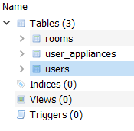
Data Requirements

Figure x: SQlite Data Tables (SO FAR in production**)
Currently uses a relational data model to persist user accounts, the user’s home layout, and appliance assignments required for energy estimation. At the current stage of development, persistence is implemented using SQLite in a local development environment, allowing rapid iteration and automatic schema evolution through Hibernate. This database layer is intended as a development datastore, with PostgreSQL planned for later deployment to provide improved concurrency, reliability, and operational support in a production setting.
The current SQLite schema consists of three core tables that represent the minimum viable data required for the implemented features:
The users table stores user account information and supports authentication. It contains a unique identifier and basic profile fields including name, email, username, and password. In the implemented system, the password value represents a hashed password rather than plaintext credentials, and user records form the ownership boundary for all other stored data. Each user is therefore the root entity for access control, ensuring that rooms and appliance assignments can be scoped to the authenticated user.
The rooms table stores the household layout created within the Map My House feature. Each record represents a room that belongs to a specific user, enforced through the user_id field. Rooms include a name, a floor label used to group rooms into floors and an optional room type field. This structure supports multi-floor households while remaining flexible enough for users with a single-floor home. The ability to associate rooms with a user is essential for ensuring that only authenticated users can retrieve and modify their own house layout.
The user_appliances table stores appliance assignments and usage assumptions for each user. Each record represents an appliance instance configured by the user and contains an appliance name, a usage type, and usage parameters such as hours per day and uses per day. Records may also include an optional custom name to support user-friendly naming. Appliance assignments are linked back to the owning user through user_id and can optionally be associated with a room through room_id. Timestamps are stored to support auditing, future change tracking, and more reliable analytics. This table is central to energy estimation as it provides the inputs required to calculate kWh consumption and cost projections.

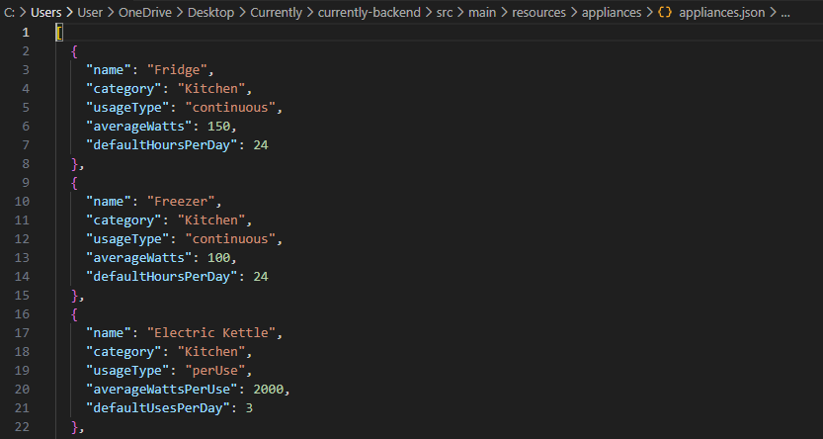
Figure x: appliance.json file with appliance electricity usage data
Also, along with the tables stored in SQLite, the system relies on a structured appliance reference dataset to provide values for appliance energy. This dataset is in a JSON file within the backend resources directory and contains a list of common household appliances with their typical characteristics, such as category, usage type, average wattage and default usage assumptions.
Each appliance entry defines whether the appliance runs continuously (e.g., fridges or freezers) or on a per-use basis (such as kettles), this lets the system to apply proper calculation logic when estimating energy consumption. Default values, such as hours of operation per day or uses per day, are automatically included to reduce user effort during appliance assignment while still allowing these hours and uses to be changed by the user. This approach balances usability with transparency, as users can clearly see and modify the values driving energy and cost estimates.
At the current stage of development, this appliance dataset is intentionally kept separate from the relational database. This design choice simplifies iteration, avoids unnecessary schema complexity during early development, and allows the dataset to be refined independently as more accurate or representative appliance data becomes available. When a user assigns an appliance through the My Appliances feature, only the fields required for calculation are persisted in the user_appliances table, ensuring that user-specific configuration is stored independently from reference data.
As the project progresses toward deployment on PostgreSQL, this dataset can be migrated into a dedicated appliances table to improve normalisation, reduce duplication, and support more advanced querying and analytics. However, for the midpoint stage, the JSON-based reference dataset provides a flexible and effective solution that supports the implemented functionality without introducing premature complexity.

User Requirements
Currently must:
- Allow users with minimal technical knowledge to create an account and begin modelling their home and choose appliances.
- Provide clear visual cues and error messages.
- Respond quickly to user interactions (under 2 seconds for most actions).
- Make it so that authenticated users can only access their own data.
- Provide meaningful energy insights that aid decision-making

Environmental Requirements
Currently must:
- Runs in any modern web browser (Chrome, Edge, Firefox, Safari).
- Backend requires Java 17+ and Spring Boot runtime.
- Database must support relational storage, SQLite for development and PostgreSQL for deployment.
- Must operate reliably on typical consumer hardware (laptop, desktop).

Usability Requirements
Currently must:
- Interface must use simple navigation through a clear top-level menu.
- Colours and typography must follow a consistent design scheme (as you can see in the variable.css).
- Room creation and appliance assignment must require no more than 3–4 steps.
- Visualisations (charts) must be readable, colour-blind friendly, and use clear labels.
- User should be able to complete core tasks without documentation.

Design & Architecture

Architectural Style
Currently is designed as a modular, full-stack web application using a layered architecture. The system separates the user interface (client) from business logic and data access (server) to improve maintainability, security and testability. This architecture supports incremental development in sprints, where features can be implemented and verified independently while still integrating cleanly into the overall system.
The application follows a client–server model:
- The React frontend provides the user interface and user interactions (forms, room mapping UI, charts).
- The Spring Boot backend exposes REST endpoints, applies authentication and authorisation controls, performs energy analytics, and manages persistence.
- The database persists user accounts, rooms, and appliance assignments. SQLite is used during development for simplicity and portability, with PostgreSQL planned for deployment.
- A separate appliance reference dataset (JSON) provides standard wattage/usage defaults.
- A planned AI recommendation module will generate advisory energy-saving suggestions based on user usage patterns.
Currently follows a client–server web architecture with a layered backend (controller → service → repository). This separation improves maintainability and testability and is aligned with “secure by design” practice. addressing design-level risks rather than relying on fixes later in development (OWASP 2010).

Tech Stack Interaction Diagram

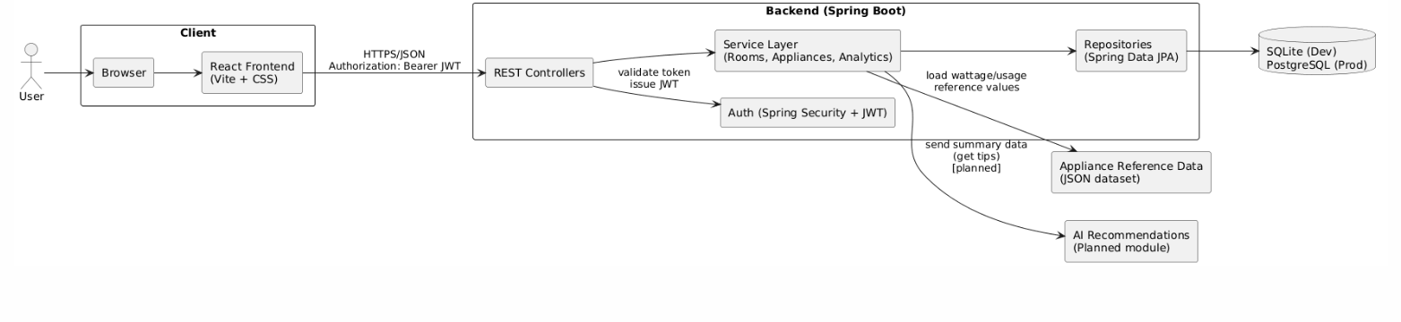
Figure 1: Currently technology stack and component interactions

High level Components
Client Layer (React + CSS)
The frontend is built from reusable React components and page-level modules that map to the user-facing pages:
- Public pages: Landing page, Sign Up / Log In
- Private pages: Dashboard, Map My House, My Appliances, Watch Your Watts
A navigation component is used to separate public and private routes, ensuring private routes are only accessible after authentication.
Backend Layer (Spring Boot)
The backend implements a layered structure:
- Controllers (API Layer)
Accept HTTP requests, validate inputs, and return HTTP responses. Controllers are kept thin by delegating business logic to services.
- Services (Business Logic Layer)
Contain core logic such as:
  - Authentication (register/login, token issuing)
  - Room management (create/read/update/delete rooms)
  - Appliance assignment (store user appliances linked to rooms)
  - Analytics (kWh and cost calculations, Biggest Eaters, forecasts)
- Repositories (Data Access Layer)
Use Spring Data JPA to abstract database operations and enforce consistent persistence patterns.
- Entities/Models (Domain Layer)
Represent persistent structures such as User, Room, and UserAppliance. This ensures clean relational mapping and supports verifiable data requirements.

Security Architecture (Auth and Access Contril)
Security is enforced primarily at the backend using Spring Security with JWT authentication:
- Users authenticate via /api/auth/signup and /api/auth/login.
- On successful login, the backend issues a JWT token.
- The frontend stores the token and includes it in subsequent requests (Authorization header).
- Protected endpoints validate the token and ensure users can only access their own resources.
This design ensures:
- Credentials are never stored in plaintext (passwords are hashed).
- Session state is not stored server-side (token-based session).
- API endpoints can be secured consistently using Spring Security filters.

Data Architecture (current and planned**)
The backend performs analytics using appliance wattage and user-provided usage parameters.
Key calculations used across Dashboard and Watch Your Watts include:
- Energy (kWh) estimation from appliance wattage and time/use parameters.
- Cost estimation by applying a tariff (€/kWh) to computed kWh.
- Ranking algorithm to identify “Biggest Eaters” by sorting appliance consumption and selecting the top N.
These algorithms are implemented server-side so results are consistent and can be verified through testing.
As part of Watch Your Watts, a planned enhancement is an AI-assisted recommendation feature that provides user-friendly suggestions to reduce electricity consumption. The AI module will use summarised appliance usage and cost contributions (per appliance and per room) to generate practical, non-invasive tips (e.g., identifying high-cost appliances and estimating potential savings if usage is reduced).
From an architectural standpoint, the AI module is treated as an optional backend service that can be enabled without changing the core data model. If unavailable, the system continues to provide standard analytics and forecasts. This ensures the AI feature remains an enhancement rather than a dependency.

Data Flow Overview
A typical interaction flow is:
- User logs in → receives JWT.
- Frontend calls protected endpoints with JWT.
- Backend validates token, loads user-owned rooms/appliances.
- Backend calculates energy/cost metrics and returns structured JSON.
- Frontend renders charts, summaries, and insights.

Implementation
Currently still in Development

Graphical User Interface (GUI)
FIGURE 4 will be the dashboard: yet to be developed
FIGURE 6 will be Watch Your Watts: yet to be developed

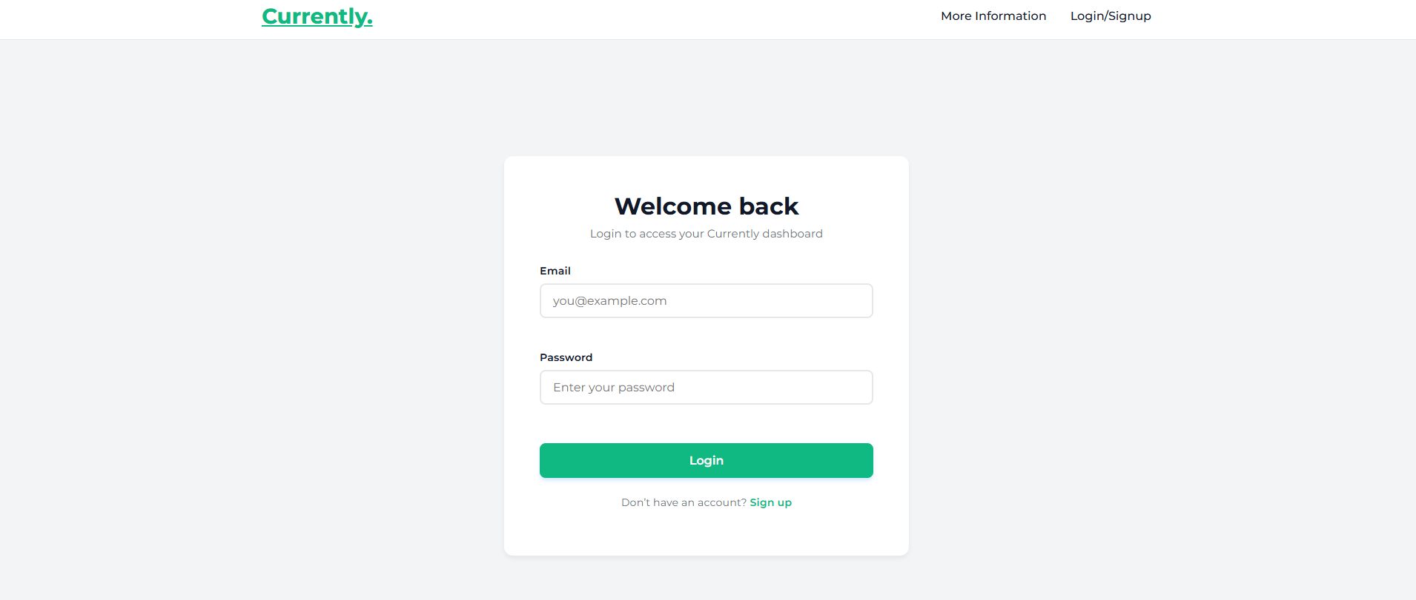
Figure 2. Login view of the Currently web application
The login view (Figure 2) is the primary entry point to the Currently web application and is designed to support frequent access while maintaining a clean and uncluttered interface. At the top of the page, a minimal navigation bar displays the Currently branding on the left and provides links to “More Information” and “Login/Signup” on the right, reinforcing the distinction between public and authenticated areas of the system. The central focus of the page is a card-style login panel positioned prominently in the middle of the screen, drawing the user’s attention directly to the authentication process.
From a technical perspective, this view is implemented as a React component using controlled form inputs and client-side validation to ensure required fields are populated before submission. When the user submits valid credentials, the form communicates with the backend authentication API; upon successful authentication, the user is redirected to the protected area of the application. The layout is responsive and centred, ensuring consistent usability across different screen sizes while maintaining a modern and professional appearance suitable for a consumer-facing web application.

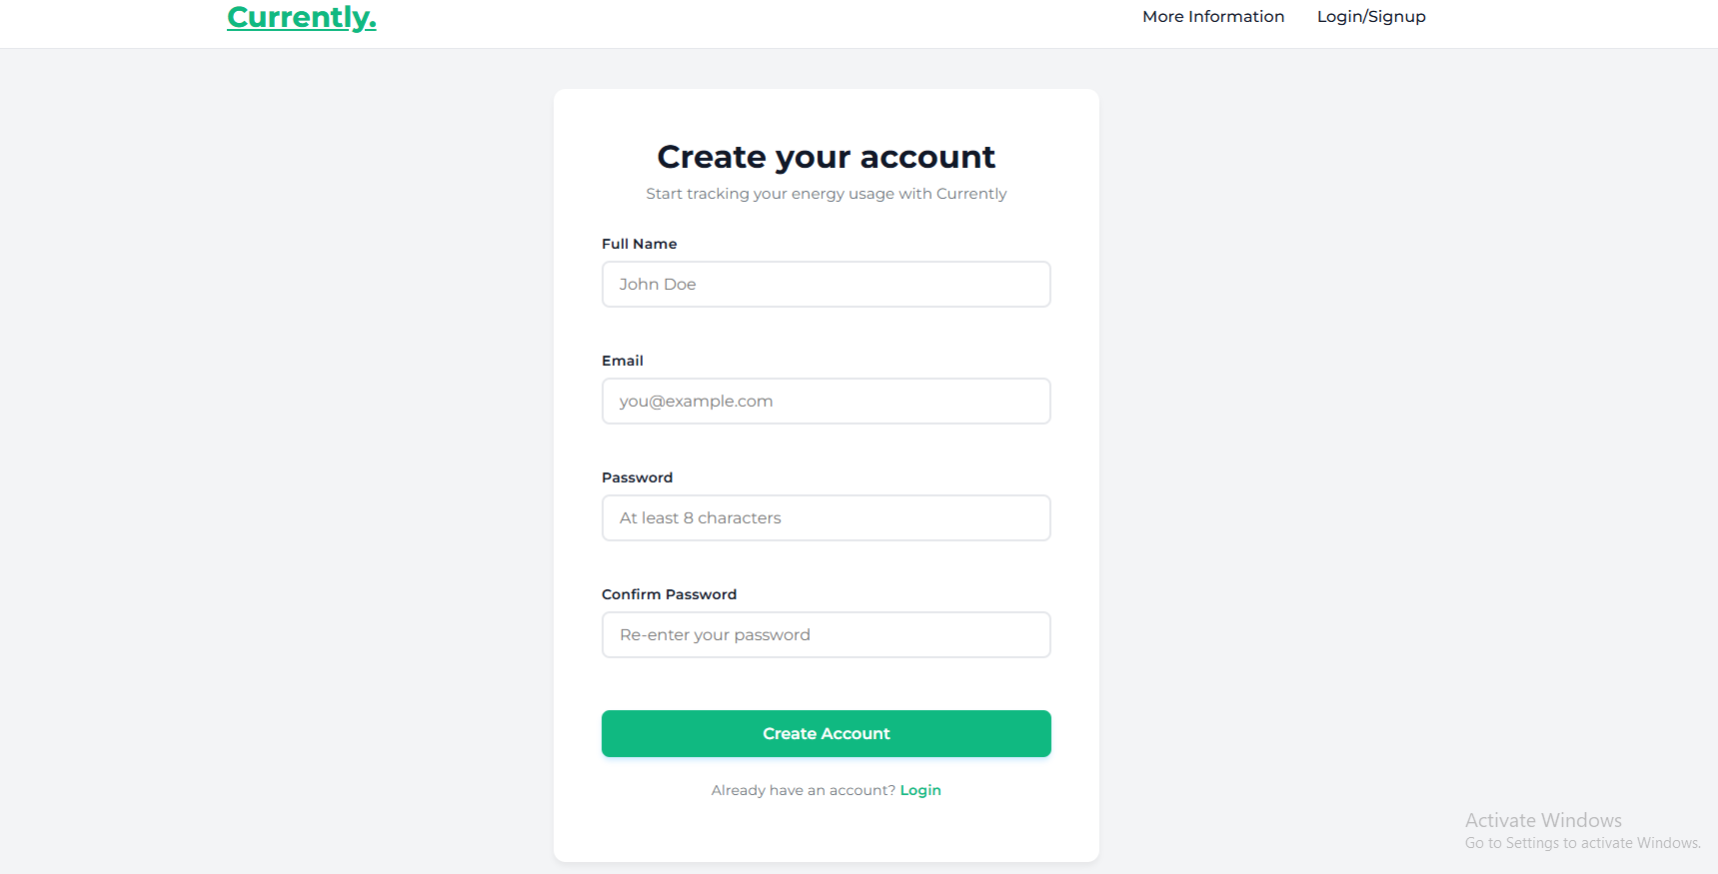
Figure 3. Sign-up view of the Currently web application
The sign-up view (Figure 3) is presented to users who do not yet have an account and is designed to make the registration process clear, guided and approachable. The page retains the same top navigation bar as the login view, displaying the Currently branding on the left and public navigation links on the right, which maintains visual consistency and reinforces the application’s identity. Centrally positioned on the page is a card-style registration form that clearly communicates its purpose with the heading “Create your account” and a short descriptive line explaining that registration enables energy usage tracking within the application.
The form is structured vertically and requests only essential information, beginning with the user’s full name and email address, followed by password and password confirmation fields. Placeholder text within each input field provides immediate guidance on expected formats, such as minimum password length, reducing the likelihood of user error.

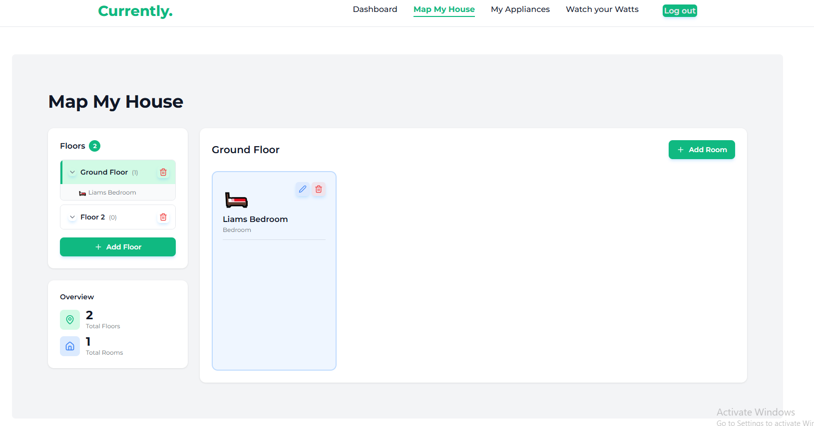
Figure 5. Map My House view of the Currently web application
The main content area is divided into clearly defined sections. On the left-hand side, a floor management panel displays the list of existing floors along with a count of rooms on each floor. Users can expand or collapse individual floors to view their rooms, remove floors when required, or add additional floors using the “Add Floor” button. Beneath this panel, an overview summary provides statistics, such as the total number of floors and total number of rooms currently defined, helping users understand the scope of their home layout.
The central workspace displays the selected floor in detail. Each room is represented as a card-style element containing a visual icon, the room name, and its room type (e.g., bedroom). Inline action buttons allow the user to edit or delete individual rooms directly from the layout, supporting quick iteration and refinement of the home model. A prominent “Add Room” button is positioned within the workspace, enabling users to add new rooms to the active floor without navigating away from the page. This design encourages a natural workflow in which users first define the structure of their home before moving on to appliance assignment and energy analysis.

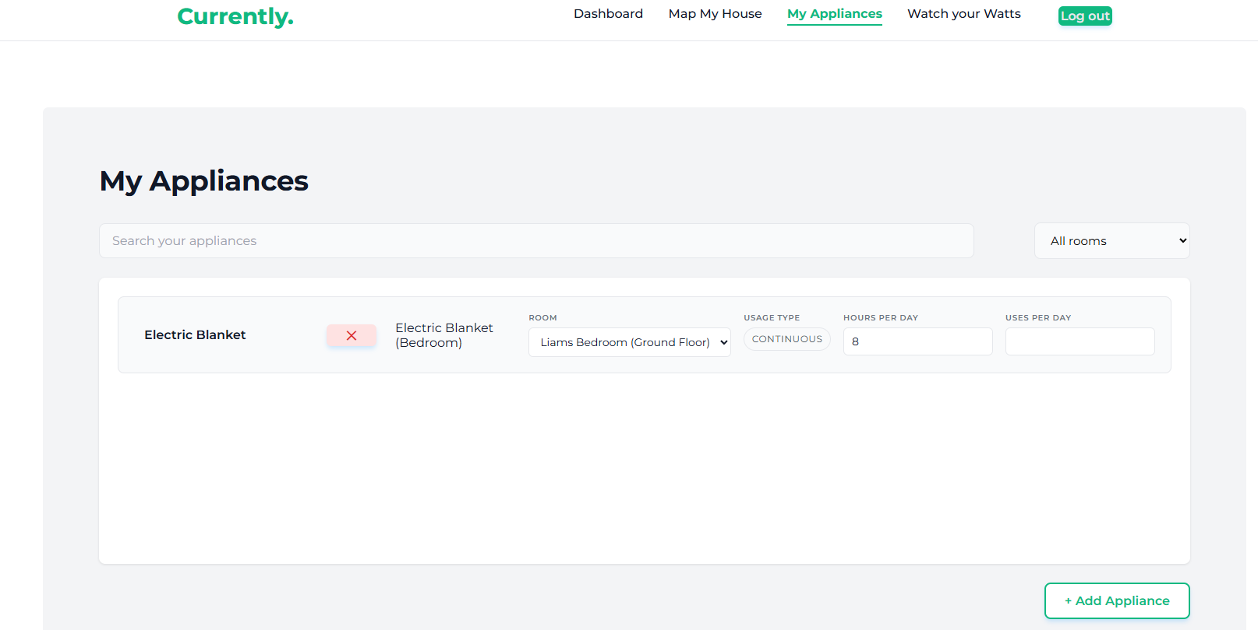
Figure 6. My Appliances view of the Currently web application
At the top of the page, a clear page heading identifies the current context, followed by a search input that enables users to quickly locate specific appliances within their list. Alongside the search field, a room filter dropdown allows appliances to be viewed by location, supporting users with larger homes or many assigned devices. The main content area presents appliances in a structured, row-based layout that exposes key configuration parameters. For each appliance, the user can see its name, the room to which it is assigned, the usage type (for example, continuous usage), and the relevant usage inputs such as hours per day or uses per day. Inline controls are provided to adjust these values directly, encouraging users to fine-tune their inputs and immediately improve the accuracy of energy estimates.
Each appliance row also includes a clear remove action, allowing devices to be deleted from the user’s profile if they are no longer relevant. A prominent “Add Appliance” button is positioned at the bottom of the page, guiding users toward expanding their appliance list and reinforcing the intended workflow of mapping rooms first and then populating them with appliances. The overall design balances clarity with flexibility, ensuring that even complex appliance configurations remain understandable and manageable.

Testing
Currently still in Development

Evaluation
Currently still in development

Conclusions
Currently still in development

Further Development or Research
Currently still in development

References
Currently Still in development

Appendices
This section contains all supplementary information to the main body of my Technical Report for Currently:

Project Proposal

Objectives
The objective of my Currently project is to design and implement a secure web application that lets users track, monitor and better understand their household electricity consumption. The system provides users with tools to model their home, record appliance usage, visualise energy consumption across different rooms and generate estimated electricity costs based on realistic usage assumptions all while making sure that all user data is stored and processed securely.
The application aims to promote energy awareness by presenting clear, structured insights into household electricity usage through many visualisations and summaries. A key part of the project is the integration of secure software engineering practices, including robust user authentication, controlled access to user-specific data, and safe data persistence making it so privacy and security are considered as core design requirements rather than secondary concerns.
A central feature of the system is the Watch Your Watts module, which is designed to provide users with forecasted electricity costs based on their current appliance configuration and usage patterns. This feature is intended to support informed decision-making by allowing users to explore how changes in appliance usage may impact overall electricity costs. As the project progresses, this functionality is planned to be extended with advisory, AI-assisted recommendations to help users identify practical opportunities to reduce energy consumption.
By combining usability, data-driven insights, and security-focused design, Currently looks to support households in managing electricity costs more effectively while also contributing to broader environmental sustainability goals through increased awareness and potential reductions in energy demand.

Background
The concept for Currently came in response to the increase in electricity prices in Ireland, particularly in the context of recent global events such as the COVID-19 pandemic and the conflict in Ukraine. These factors have contributed to rising energy costs, with projected price increases of between 9% and 13.5% across major electricity providers from October 2025. This trend presents both financial and environmental challenges for households, highlighting the need for accessible digital tools that improve transparency, support cost management and help users make more informed decisions about their energy consumption.
A web application was selected as the delivery platform for this project due to its accessibility and its suitability for integrating multiple computing disciplines studied during the course, including software development, data management and secure coding practices. By bringing all these areas into a single system, the project provides an opportunity to demonstrate both technical competence and applied cybersecurity awareness within a realistic, consumer-facing application.
The objectives outlined in Section 1.0 are addressed through features that enable users to view estimated usage statistics, digitally map their household structure, and assign appliances to specific rooms. These inputs are then used to generate predictive cost estimates and simulated energy savings, allowing users to explore how changes in behaviour may affect their electricity bills. By combining usability, data security and sustainability-focused design, Currently looks to deliver practical value to end users while also fulfilling the academic goals of the programme and promoting more environmentally responsible energy usage.

State of the Art
Several applications and platforms currently exist to help households understand and manage their electricity consumption. In Ireland, utility providers such as Bord Gáis and ESB offer online customer portals that allow users to review historical electricity usage, normally presented on a monthly or quarterly basis. Also, smart home technologies such as Google Nest, Hive, and various smart plug solutions enable real-time monitoring of electricity usage at the device or circuit level. While these systems can provide accurate consumption data, they are often dependent on proprietary hardware, involve upfront costs, or present information in a way that lacks meaningful context at the level of individual rooms or appliances.
Many existing solutions focus primarily on raw consumption figures rather than on helping users interpret how different appliances and behaviours contribute to overall energy usage. As a result, users may be able to observe that their consumption is high without clearly understanding which appliances or rooms are responsible, or what practical steps could be taken to reduce costs.
What distinguishes the Currently project is its emphasis on accessibility, usability, and software-based analysis. Unlike hardware-dependent solutions, the system does not require additional devices or installation. Instead, it uses an appliance-level reference dataset combined with user-inputted usage assumptions to generate estimated consumption and cost insights. Features such as Map My House and Watch Your Watts are designed to provide intuitive visualisations and predictive simulations that help users understand the relationship between their household structure, appliance usage, and electricity costs. In addition, the project incorporates a strong cybersecurity focus, ensuring that user data is stored and processed securely.
By combining clear visual design, appliance-level insights and secure data handling, Currently offers a UI friendly alternative to existing energy monitoring tools, made to help others in the growing challenge of rising electricity costs in Ireland.

Technical Approach
The development of Currently follows an Agile-inspired workflow structured around self-managed sprints. Although the project is developed by a just me, this approach supports iterative development, incremental feature delivery and regular reflection on both functionality and usability. Each sprint focuses on a defined set of objectives, with outcomes reviewed before progressing to subsequent stages, ensuring that development remains aligned with the overall project goals and academic requirements.
System requirements are identified through a combination of academic research into energy monitoring applications, analysis of existing consumer platforms, and consideration of end-user needs. Attention is given to clarity of data presentation, secure user authentication and the provision of actionable insights rather than raw consumption figures. Both functional requirements, such as secure login, household mapping, appliance assignment and energy forecasting, and non-functional requirements, including usability, scalability and security, are addressed progressively throughout the sprint cycle.
Project tasks, milestones, and development progress are documented using Notion, which serves as a central repository for sprint planning, timelines, and technical notes. The frontend of the application is implemented using React and CSS, enabling a responsive, component-based user interface suitable for incremental enhancement. The backend is developed using Java Spring Boot, which provides a structured framework for building secure RESTful APIs. User authentication and access control are implemented using Spring Security with JWT-based authentication, aligning with established best practices for stateless web application security and addressing common risks identified in the OWASP Top 10, such as broken authentication and access control failures (OWASP, 2023).
For data persistence, the project uses a relational data model managed through Spring Data JPA. SQLite is used during local development to simplify setup and iteration, with a planned migration to PostgreSQL for deployment to support scalability and production readiness. Appliance definitions are maintained as structured reference data and combined with user-provided usage assumptions to generate energy consumption and cost estimates. These calculations are performed server-side to ensure consistency and integrity.
In addition to core analytics, the technical approach includes a planned AI-assisted recommendation feature integrated into the “Watch Your Watts” module. This feature is intended to analyse summarised appliance usage data and provide advisory suggestions to help users identify potential opportunities to reduce electricity consumption. The AI component is treated as an optional enhancement rather than a dependency, ensuring that the system remains functional without it and that recommendations remain transparent and user-controlled, in line with responsible AI principles (OECD, 2019).
System planning and interface design are supported through lightweight wireframing tools and PlantUML, which is used to model system architecture and workflows. By combining an Agile-inspired development process with structured planning, secure-by-design principles, and iterative refinement, the project aims to deliver a user-friendly and secure energy monitoring application that meets both its functional objectives and academic evaluation criteria.

Technical Details
The Currently application is implemented as a full-stack web system using React for the frontend and plain CSS for styling. This combination supports a clean, responsive, and user-friendly interface while allowing the application to be structured into small, reusable components that are easier to maintain and extend. The frontend is responsible for handling user interactions such as authentication, room creation, appliance configuration, and the presentation of energy data. Information is displayed through structured layouts, dashboards, and room-based views, with graphical visualisations used to help users interpret estimated energy consumption and costs. Interactive charts are implemented using established charting libraries suitable for React-based applications, enabling clear and responsive visual feedback as user inputs change.
The backend of the application is developed using Java Spring Boot, which provides a robust framework for building secure RESTful APIs and integrating business logic with persistent storage. Data access is managed using Spring Data JPA, allowing the application to interact with a relational database in a structured and maintainable manner. During development, SQLite is used as the database engine to simplify local setup and iteration, while PostgreSQL is planned for deployment to support scalability, concurrency, and long-term data management. User accounts, rooms, and appliance assignments are stored relationally, while predefined appliance characteristics are maintained as structured reference data that can be migrated into the database at a later stage if required.
Energy consumption calculations are performed on the server side to ensure consistency and integrity. Estimated daily energy usage is calculated by combining appliance wattage with user-provided usage parameters, such as hours of operation per day or number of uses and converting the result into kilowatt-hours. Cost estimates are then derived by applying an electricity tariff expressed in euros per kilowatt-hour. A default electricity tariff value is used as a baseline when calculating estimated costs, expressed in euros per kilowatt-hour (€/kWh). This value is derived from publicly available Irish electricity pricing data, which indicates an average household electricity cost of approximately €0.34 per kWh. This tariff is used for estimation purposes only and can be adjusted or personalised in later iterations of the system (Selectra, 2024). These calculations form the basis of the Watch Your Watts feature, which enables users to explore projected costs and to simulate potential savings by reducing appliance usage.
Security considerations are integrated throughout the system architecture. User authentication and access control are handled using Spring Security with JWT-based authentication, ensuring that only authenticated users can access private functionality and that all user-owned data is properly scoped. Passwords are stored using secure, one-way hashing, and all user input is validated to reduce the risk of misuse or common web application vulnerabilities. By enforcing these controls at the backend level, the system ensures that security is applied consistently across all client interactions.
Overall, the technical design combines a modern, interactive frontend with a secure and structured backend. This approach supports accurate energy estimation, clear data presentation, and strong protection of user information, resulting in a data-driven application that helps users better understand their energy habits and make informed decisions about electricity usage.

Special Resources Required
This project does not require any specialised physical resources. All development and testing will be carried out using standard computing equipment, including a personal computer capable of running development environments for React and Java Spring Boot.

Project Plan
The project is structured around a series of iterative, time-boxed sprints, each lasting approximately one to two to three weeks, depending on difficulty. This sprint plan reflects both the original planning documentation and the actual progression of development to date.
Sprint 1: Project Setup and Architecture (October 23rd – October 30th)
- Initialise Git Repo, set up folder structure(frontend, backend & docs)
- Configure Spring Boot backend with PostgreSQL DB
- Set up react frontend
- Task create base react components & routing
- Create Notion workspace For sprints and documentation
- Task Add basic README & Project Guidelines
Sprint 2: Authentication & User Management (November 1st - November 12th)
- Backend: Spring Security, JWT and password hashing in place
- Frontend: Initial landing page, Sign Up/ Log In pages, forms and validation
- Connect Frontend to Backend API points
- Test user auth and session management
- Document authentication flow
Sprint 3: My Applications Feature (November 12th -25th)
- Backend: CRUD API for appliances (room → appliances)
- Frontend: Appliance assignment, selection from DB
- Store appliance usage hours and wattage
- Test user flows from room creation → appliance assignment
Sprint 4: Map My House (November 25th – December 10th)
- Backend: CRUD API for rooms (user → rooms)
- Frontend: Map My House page, room creation UI, multiple floors
- Link rooms to user accounts
- Unit test room creation & retrieval
- Configure “My Appliances” to work alongside Map my house
Mid-Point Requirements (December 12th-18th)
- Presentation Slides
- Technical Report
- Update Project Proposal
Sprint 5: Dashboard Development (January 6th – January 26th )
- Create Backend with API endpoints getting appliance + room data
- Frontend: build dashboard page in line with Wireframes
- Fetch and display live user data, make sure “no data scenario” is handled for new users
- QA: validate accuracy of fetched data and verify authentication and data privacy
- Appliance DB: Create JSON file with list of household appliances which users can assign in “my Appliances”

Sprint 6: Watch your Watts Page (January 27th – February 23rd )
- Backend: API endpoints to calculate room consumption and top 5 appliances
- Frontend: Pie charts (Recharts/Chart.js) for rooms
- Cost forecasting based on appliance usage
- Connect predictive model for reduced consumption scenarios
- Test correctness of calculations and visuals
Sprint 7: Integration and Security Hardening (February 24th – March 16th)
- Test all API connections & user flows
- Add input validation & error handling
- Review password storage, JWT expiry, and secure endpoints
- Document security measures in SECURITY_NOTES.md
- Begin writing integration tests
Sprint 8: Testing & Debugging (March 17th – April 6th)
- Unit tests for backend services (JUnit/Mockito)
- Integration tests for API & frontend
- Test predictive module accuracy
- Ensure database consistency and error handling
- Prepare test report
Sprint 9: Final Feature Enhancements (April 7th – April 20th)
- Add optional features, Optimise performance (frontend rendering, backend queries) Update diagrams and architecture documents
- Changeover from SQLite to PostgreSQL
Sprint 10: Documentation and Deployment Prep (April 21st – April 30th)
- Finish Technical Report
- Research deployment methods (if deployment required)
Sprint 11: Any Final Tests and Submission Polish (April 26th – May 1st)
- Regression tests of all modules
- Proofread documentation, check academic compliance
- Final code review and GitHub commit history clean-up
- Prepare submission zip and presentation slides

Testing
The Currently system will be tested using a structured combination of functional verification, security testing, and user-centred evaluation to ensure that the application is correct, secure, and usable. Testing is treated as an ongoing activity throughout development rather than a single final stage, with evidence gathered at each milestone to validate that the system remains stable as new features are introduced.
Technical testing will include unit, integration, and system-level testing. Unit testing will focus on isolated backend components such as energy-consumption calculations, tariff application, cost forecasting logic, and data-validation routines. These tests are intended to confirm that calculation outputs remain correct across a range of realistic and edge-case inputs, for example appliances with very low wattage, unusually high usage durations, or missing optional values. Where practical, unit tests will also verify repository and service behaviour to ensure that user-owned data is correctly scoped and that basic CRUD operations behave as expected. Integration testing will validate the interaction between the frontend and backend, confirming that authenticated requests successfully retrieve and persist rooms, appliance assignments, and analytics outputs. Attention will be given to API behaviour around authentication, ensuring that protected endpoints reject missing or invalid JWT tokens and that the system does not expose user data through insecure direct object references. This aligns with common web application risk categories identified in the OWASP Top 10, particularly broken access control and identification/authentication failures (OWASP, 2023).
System testing will verify complete end-to-end workflows from the user’s perspective, including account creation, login, room creation within Map My House, appliance assignment through My Appliances, and the production of forecasts and insights through Watch Your Watts. These tests will confirm that all modules work together consistently, that state is persisted correctly between sessions, and that the user interface responds predictably when data changes. In addition, regression testing will be performed whenever major changes are made to authentication, database structure, or analytics logic, ensuring that existing functionality is not unintentionally broken during sprint development.
Because the project has a cybersecurity focus, security testing will form a dedicated part of the testing strategy. Automated dynamic analysis will be carried out using OWASP ZAP to scan the running web application for common vulnerabilities, including missing security headers, insecure cookie settings, authentication weaknesses, CORS misconfiguration, and input-handling vulnerabilities such as reflected XSS or injection risks where applicable. ZAP will be used both in passive scanning mode during normal browsing of the application and in active scanning mode against relevant endpoints, with findings documented and addressed where appropriate. This provides structured evidence that security concerns have been actively assessed using an industry-recognised toolset. In addition to automated scanning, targeted manual security checks will be performed, including verification of password hashing behaviour, validation of token expiry and token rejection behaviour, and confirmation that sensitive endpoints cannot be accessed without a valid JWT. Where relevant, security configuration will also be reviewed against the OWASP Application Security Verification Standard (ASVS) to ensure that key authentication and access-control expectations are met at an appropriate level for the scope of the project (OWASP, 2023).
To ensure that energy predictions and cost forecasts are realistic, test cases will be built using carefully prepared appliance reference data drawn from credible sources and common household assumptions. Validation will include checking that kWh calculations correctly reflect wattage and usage duration, that cost outputs scale proportionally with tariff changes, and that “Biggest Eaters” rankings remain consistent with consumption values. Where appropriate, results will be cross-checked manually using independent calculations to ensure that the application’s outputs are transparent and explainable rather than treated as black-box results.
This testing strategy is intended to produce evidence not only that the system functions correctly, but also that it remains secure and usable as development progresses toward the final submission. References to OWASP resources are included to ensure the security testing plan aligns with established industry guidance and to support traceability in the final report’s references section (OWASP, 2023).

Reflective Journals
(ONLY September Oct and November have been Completed)

Month: September

What?
Reflect on what has happened in your project this month?
This month, I concentrated on setting up the foundations of my project. I decided to move away from using smart plugs and instead simulate appliance usage through a database which I a=will create iwtth common household devices. I set up my workflow using Notion for documentation and task management, Figma for design mock-ups and PlantUML for diagrams. I also planned to structure my work in small, agile style “sprints” to make steady progress.

So What?
Consider what that meant for your project progress. What were your successes? What challenges remain?
This gave me clarity on the project’s technical direction. By focusing on simulated data, I can avoid hardware which may be tricky to implement and still demonstrate how energy monitoring can be tracked and displayed. A success this month was refining the project scope so it’s both realistic and achievable. The challenges are still mainly about how to structure the appliance database, how to ensure the data feels realistic to users, and how to design the web app in a way that shows energy consumption.

Now What?
What can you do to address outstanding challenges?
To face these challenges, I will focus next month on building the initial database of appliances with the average usage values. I will also start on an early prototype of the Java code and initial app to test how the data can be displayed in a user-friendly way. Breaking this into smaller milestones will help me manage the workload and make sure I have steady progress without the project becoming too hard.

Month: October

What?
Reflect on what has happened in your project this month?
This month, I focused mainly on creating the appliance database that will run the energy estimation features of my project. I completed the design of a unified JSON schema for all appliance types and researched accurate wattage values across most of the commonly found household appliances. I created the full JSON dataset, which is now ready for backend usage. I also finished an architectural decision for Sprint 3: instead of splitting appliances into two separate files, I moved forward with a single JSON file using a usageType field to distinguish continuous devices from per-use devices. This work became a new task added to my sprint plan and was fully completed this month.

So What?
Consider what that meant for your project progress. What were your successes? What challenges remain?
Getting the authentication system working was a major step because the entire private side of the app depends on it. Until now, the lack of a reliable login system was blocking features like Dashboard, Map My House, and My Appliances. Implementing JWT authentication, password hashing and secure routes means the foundation of the whole platform is now stable. It also forced me to work through real challenges, everything from Java/Maven version issues to circular dependencies inside Spring Security. Everything was a learning curve and plenty of research was needed.

Now What?
What can you do to address outstanding challenges?
Next month, I will start integrating the appliance database into the backend by building the models, services, and endpoints needed to retrieve appliance details and perform usage calculations. I will also use my frontend diagrams and frameworks

Month: November

What?
Reflect on what has happened in your project this month?
This month, I focused on building out two major user-facing features: My Appliances and Map My House. I connected both sections to the backend so users can create rooms, add appliances, and manage their household layout through the app. The My Appliances page now pulls data from the appliance database I created earlier, and users can assign appliances to specific rooms. Map My House also became functional, allowing users to add floors, create custom room names, and build the structure of their home inside the app.

So What?
Consider what that meant for your project progress. What were your successes? What challenges remain?
Completing My Appliances and Map My House was a key milestone because these features form the backbone of how users interact with their data. They also directly support the energy-tracking features described in the system overview . Now that users can build their home layout and assign appliances to rooms, the project is much closer to supporting energy-estimation and analytics in later sprints.
Preparing the midpoint documentation and presentation introduced new challenges. It required pulling together work from multiple parts of the system, including diagrams, architectural decisions, and sprint progress. The challenge wasn’t just writing everything—it was organising it in a way that clearly shows the project’s structure and progress so far. Making sure the documentation matched the technical reality of the project and the expectations of the assessment took more time than expected.

Now What?
What can you do to address outstanding challenges?
Next month, I will continue building toward the midpoint submission by finalising the documentation, diagrams, and presentation material. I also plan to move into implementing the energy calculation features, starting with basic usage estimations and endpoints that return consumption data. With the core structure (authentication, rooms, appliances) now in place, the next step is to connect user inputs to meaningful energy insights.

